Accessible drop-off and pickup instructions

From Constitution Avenue turn into Constitution Place (sometimes called Lyric Lane and Theatre Lane).
You can enter Constitution Place from both the Northbound and Southbound directions.
Be aware that Constitution Place is two-way traffic and is a 10km shared zone with pedestrians.
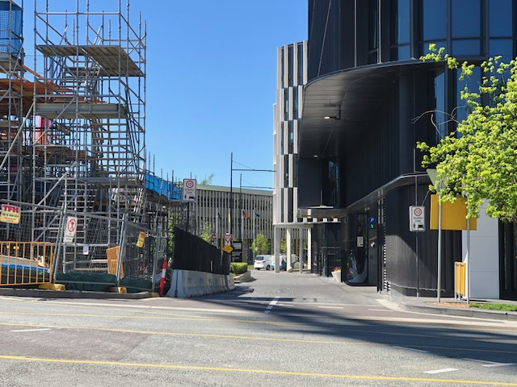
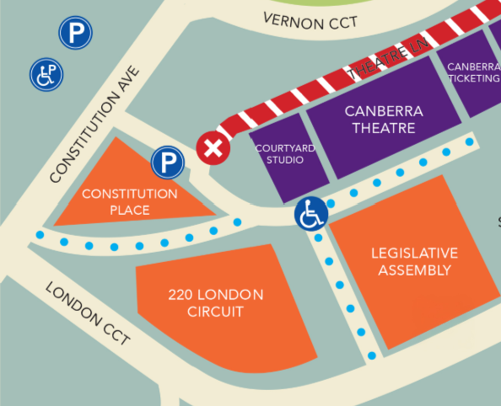






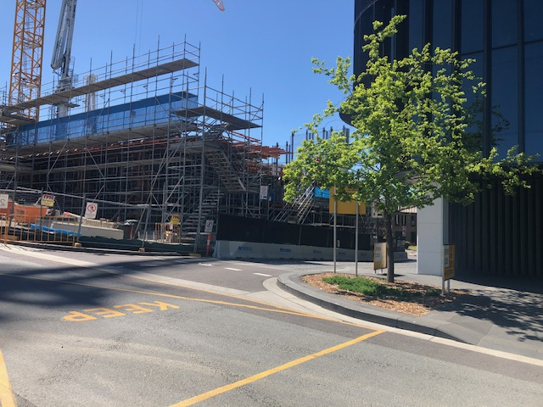
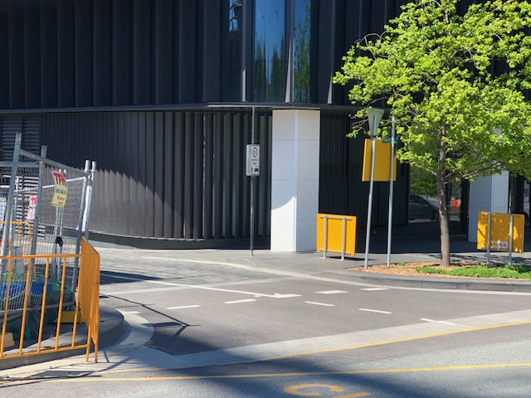

Follow the lane towards the Legislative Assembly Building.
You will see the Constitution Place car park entrance on your right where there are 225 public parking spaces and 7 accessible spaces.
More information about this Car Park can be found on their website.
Do not turn left into Theatre Lane as the road is closed for construction of the Lyric Theatre.
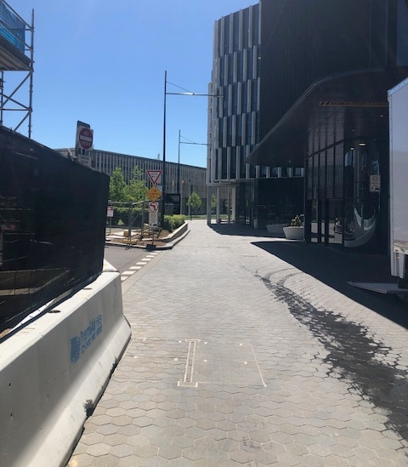




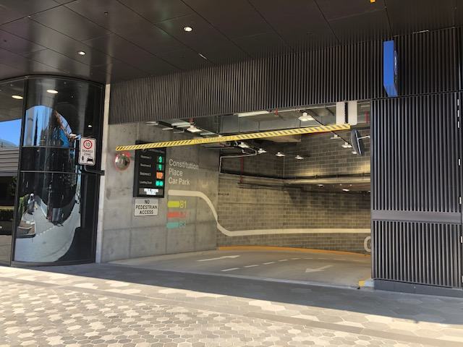
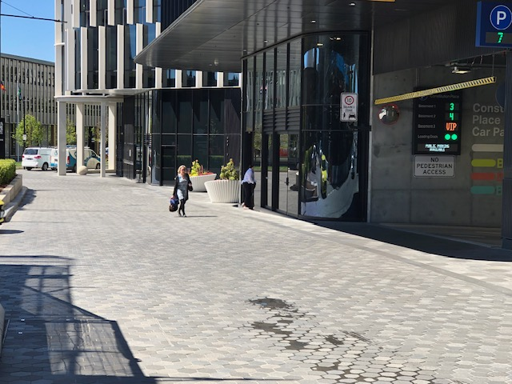
Continue forward on Constitution Place towards the Legislative Assembly Building. Veer left.
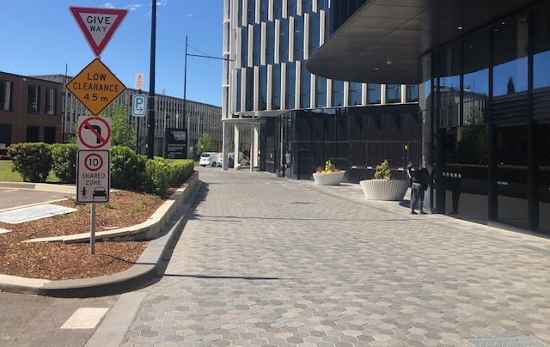



You will approach an open plaza which is where you can drop off passengers before parking or pick up passengers after the performance.

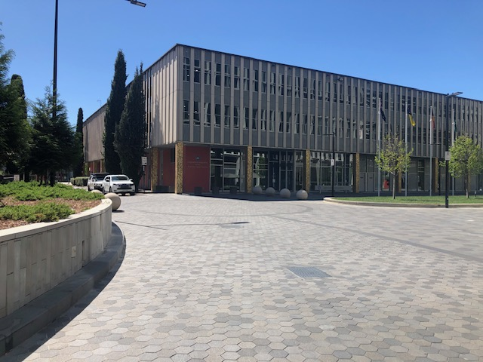
The drop off and pick up area is outside of The Courtyard Studio.
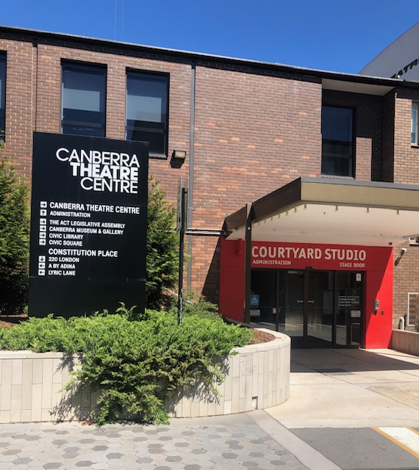

You will be able to turn around in this plaza and exit to either Constitution Place Car Park or other parking areas.
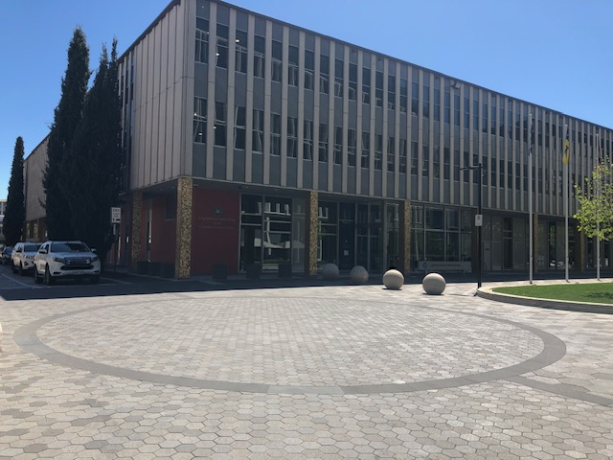



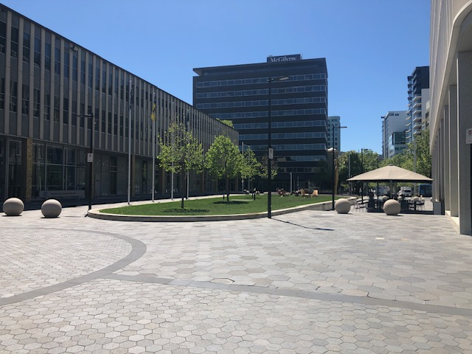

This is also the drop off and pick up area for Canberra Elite Taxis known as CAB SPOT 11. They can be contacted for bookings on 02 6126 1600.
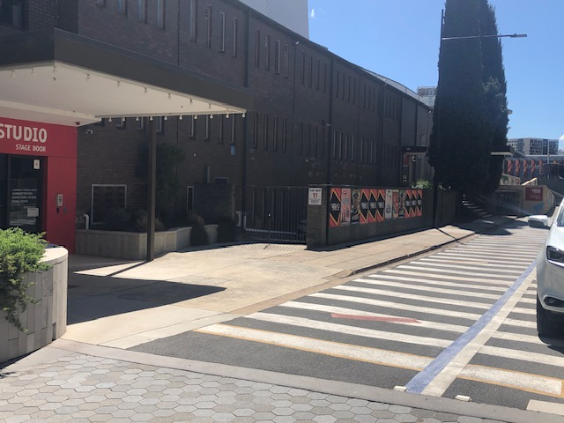
There is a 15-minute disabled parking space if you need to accompany someone into the theatre before parking.


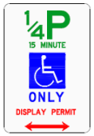
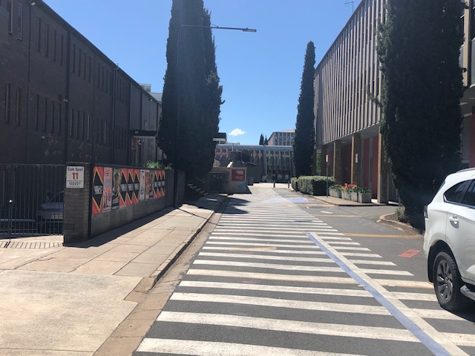
The distance to the Canberra Theatre Centre Main Entrance from these drop off and pick up zones is 120 meters.
Follow the laneway towards the Main Entrance.
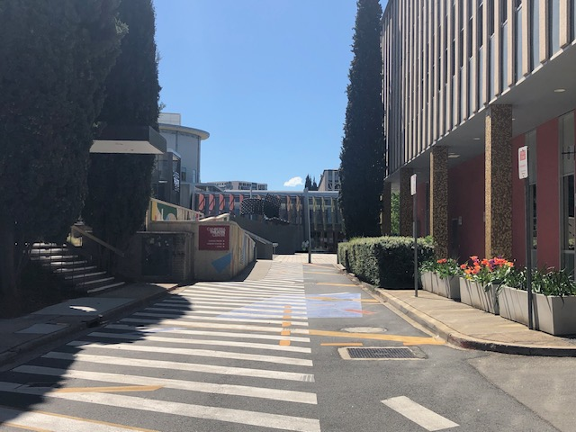

The access ramp is just on the left after this sign.
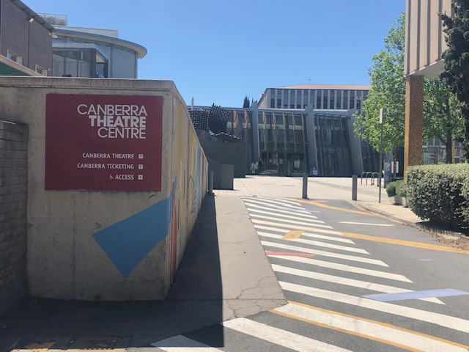
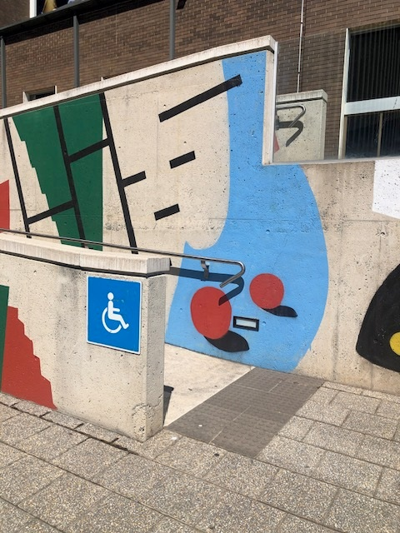


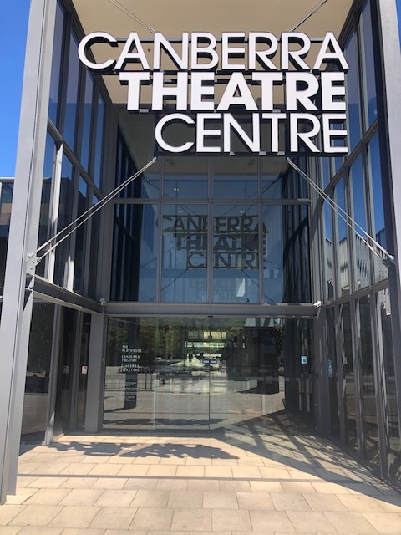
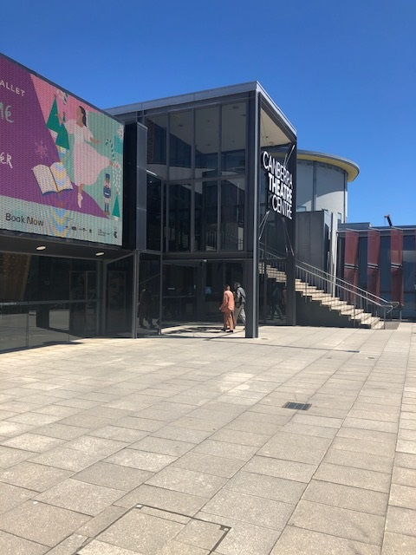
At the top of the ramp, the Main Entrance is just ahead.

When you enter the building, turn right for The Playhouse, the Link Bar and bathroom facilities.
There are chairs and tables on your right, and the Link Bar is on your left. The Playhouse entrance is directly ahead.
Bathrooms are located at the far end of the bar on the left.
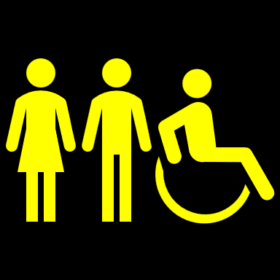
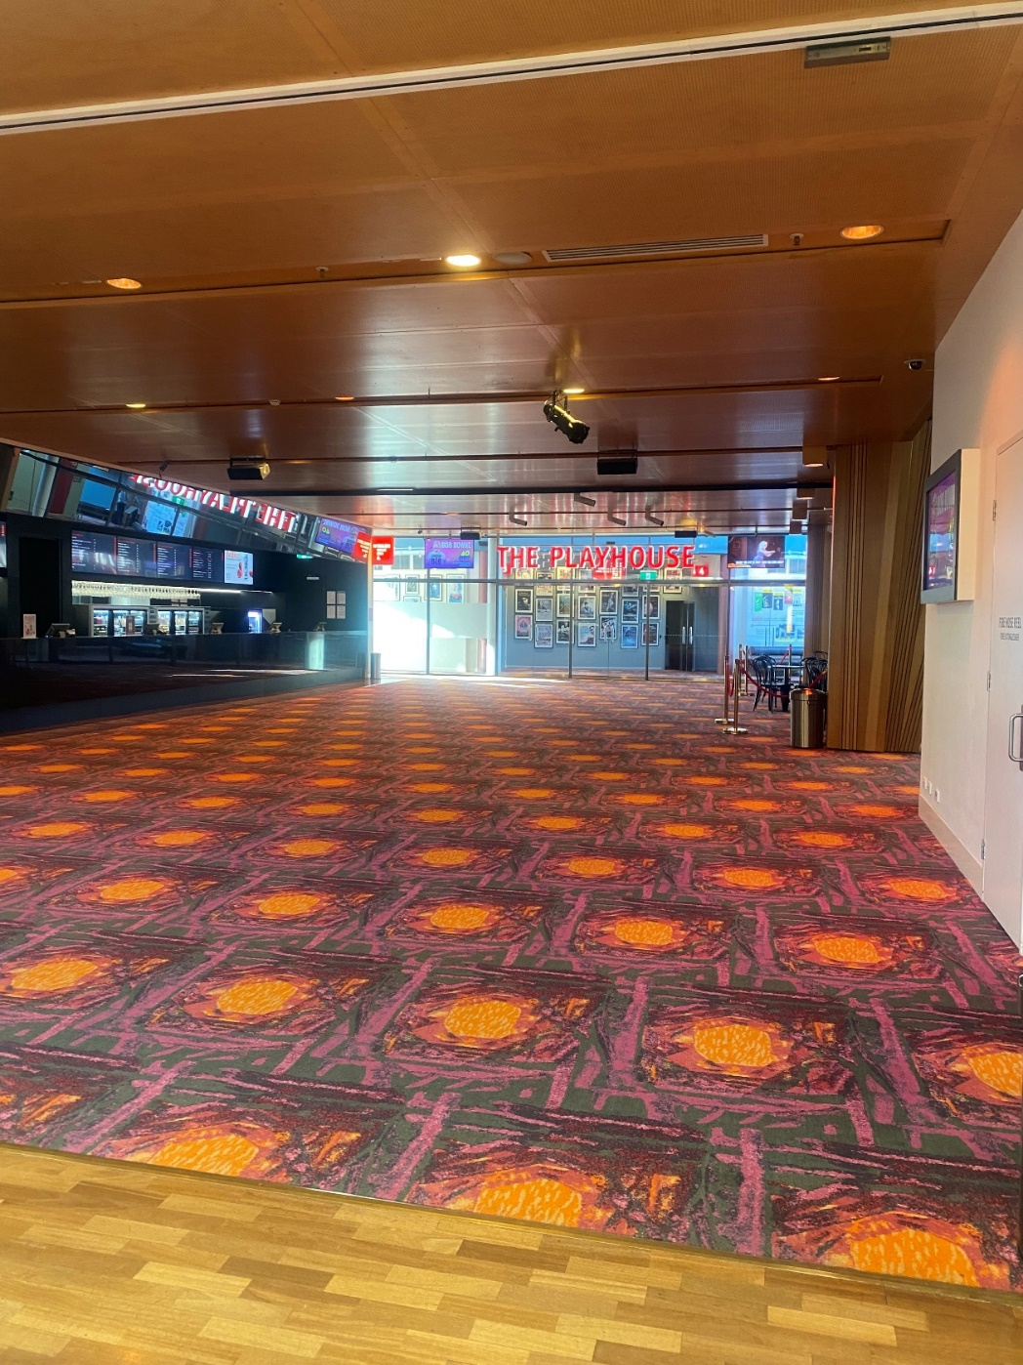

When you enter the building, turn left for The Canberra Theatre plus additional bathrooms and seating.
Our friendly team are available at the Main Entrance if you have any questions.

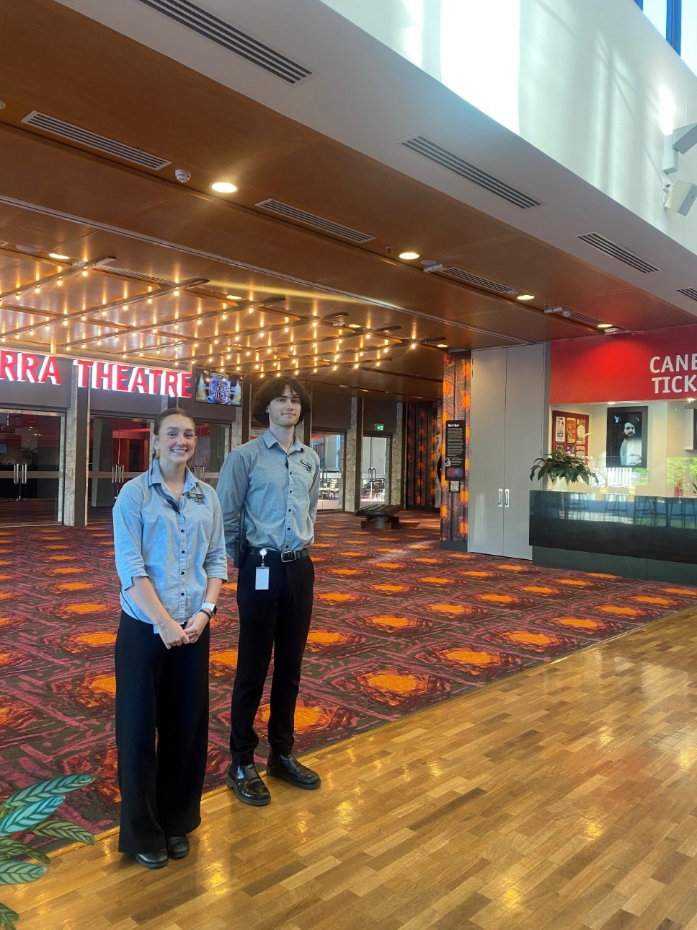

From the Main Entrance, if you need to pick up your tickets at the Box Office, go straight ahead and the counter will be on your left.


